Table of Contents

1.0 Most important SQL commands 1

2.0 All SQL Keywords 4

# Most important SQL commands

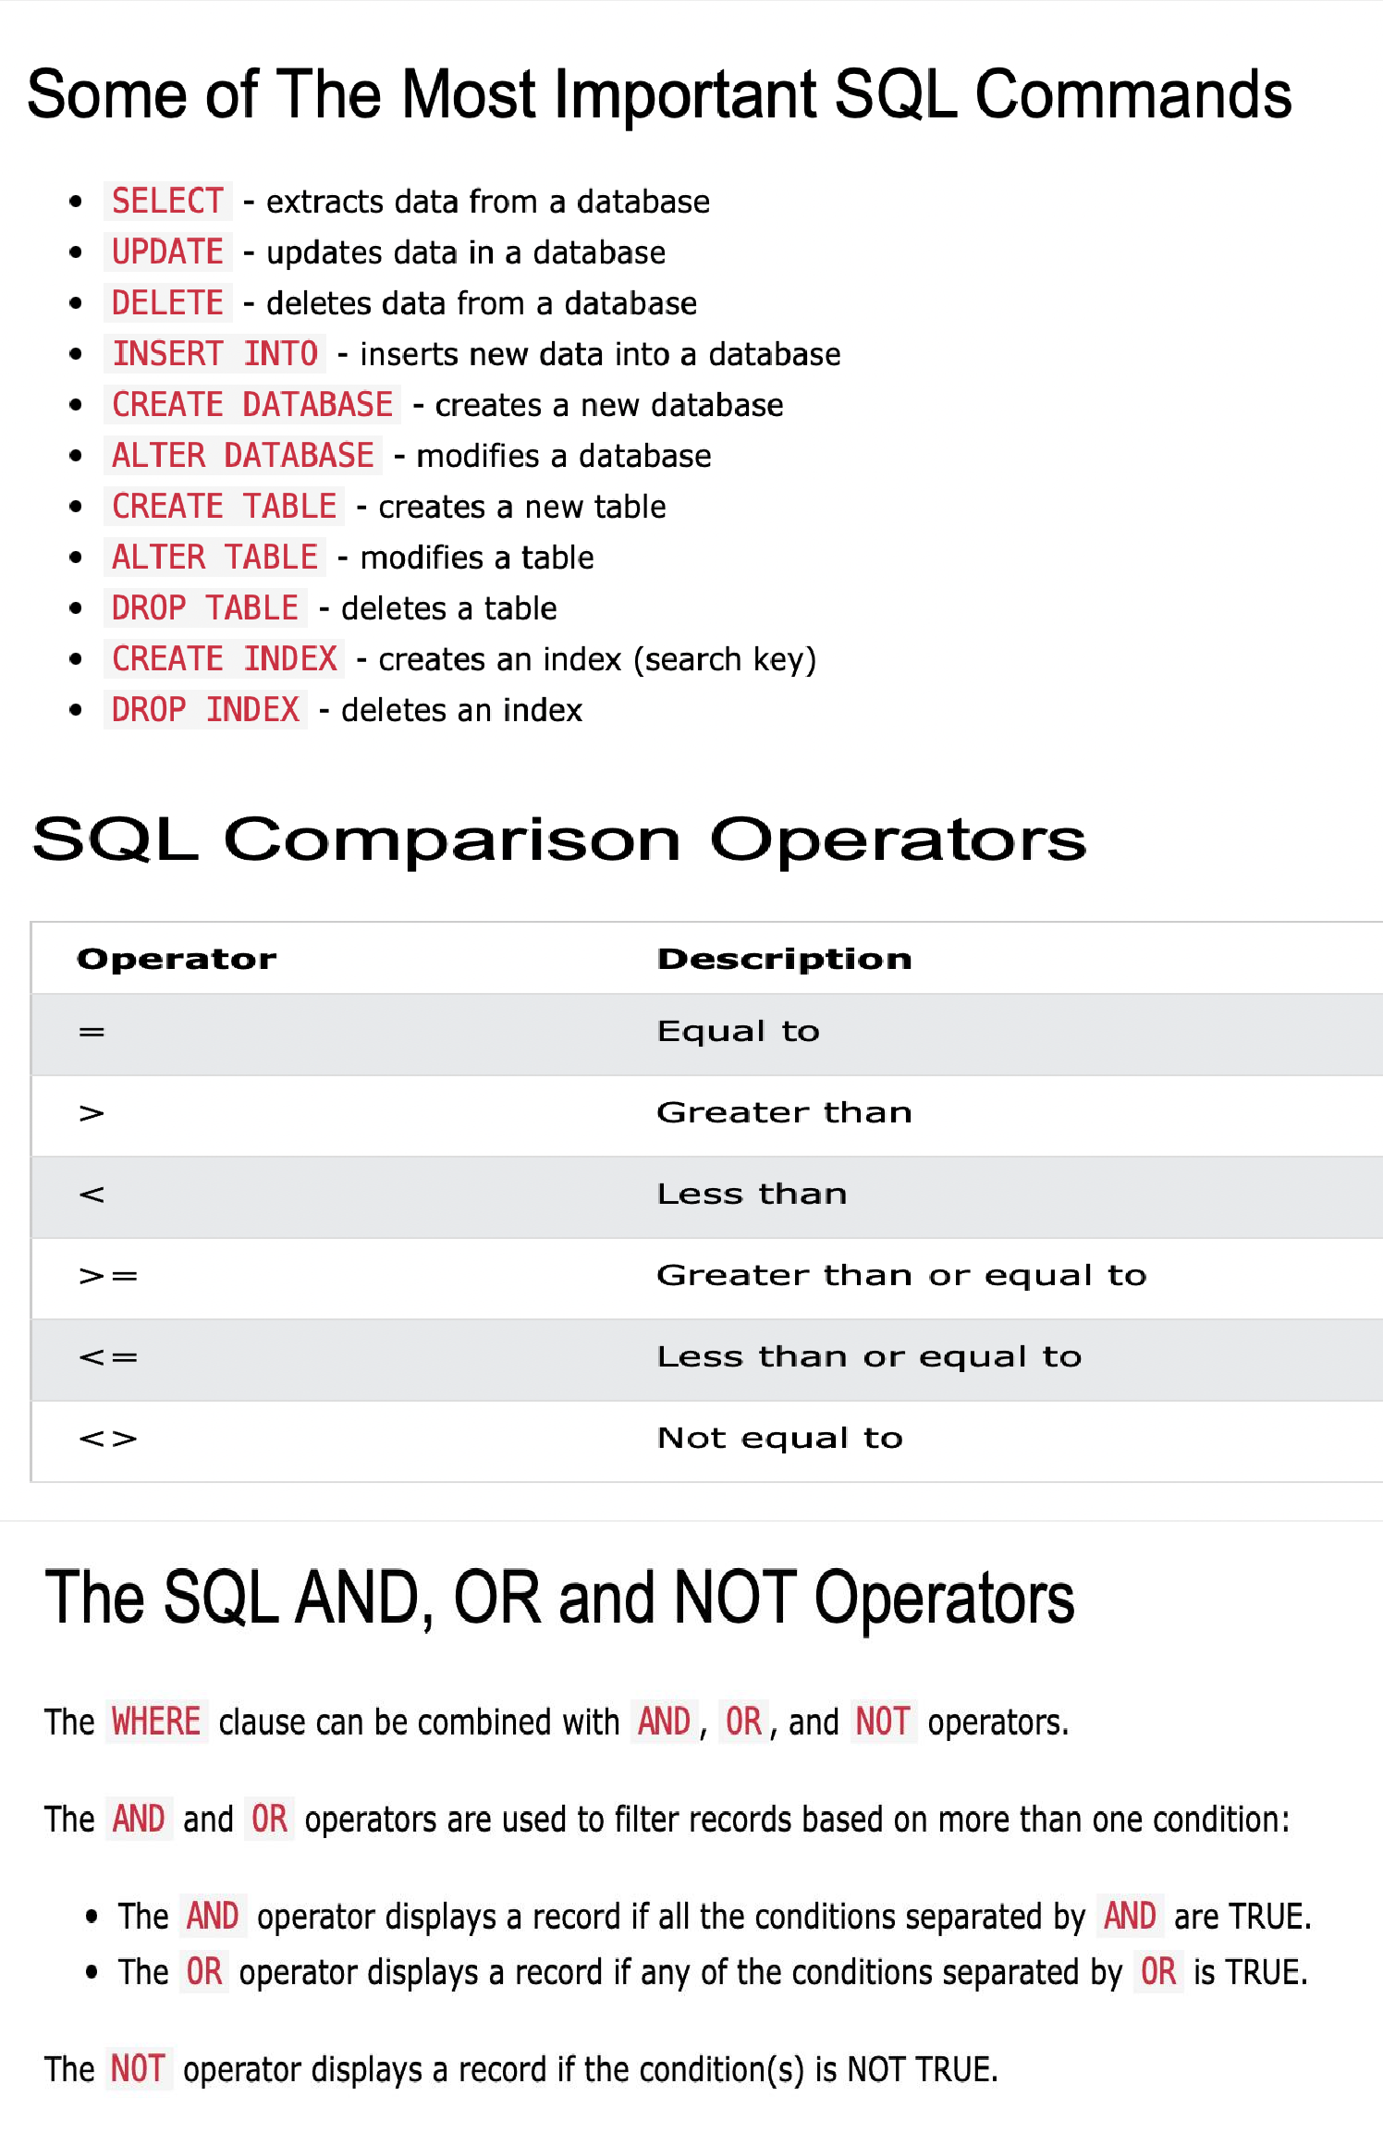

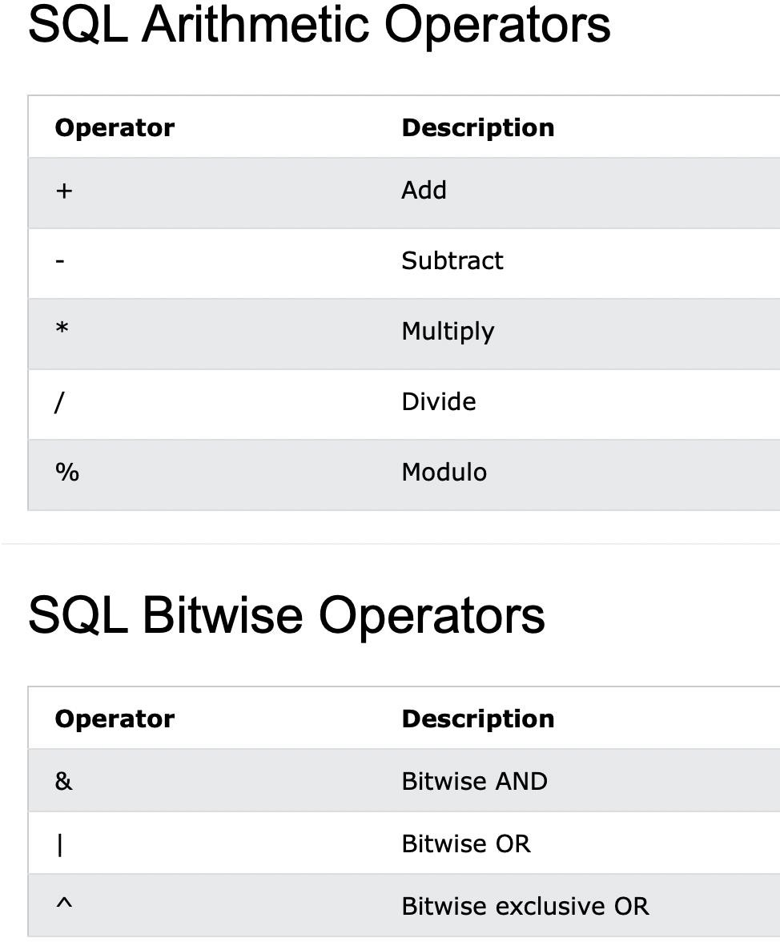

# 2.0 All SQL Keywords

